Have a practical nature…….like to solve problems?
Carpentry & Joinery could be the right choice for you!
Build up a range of skills and knowledge, developing the expertise you need to become a joiner in the construction industry.
You will discover a career, full of life skills, that makes the most of your creativity. You will have the opportunity to learn through practical activities and fundamental theory sessions gaining the knowledge and understanding needed to become a qualified joiner
As you progress, you will gain thorough training and experience in carpentry and joinery, preparing you for work on different types of sites, from private houses to large building sites.

The main areas covered on the Carpentry and Joinery Level 2 programme are:
Health, safety and welfare in construction
Principles of building construction
Information and communication
First fix flooring and roofing
First fix frames, partitions and stairs
Second fixing operations
Carpentry maintenance
Setting up and operating a circular saw
Explore careers- National Careers Service Click on link for information regarding a career in carpentry
https://nationalcareers.service.gov.uk/job-profiles/carpenter
The value of maths in carpentry

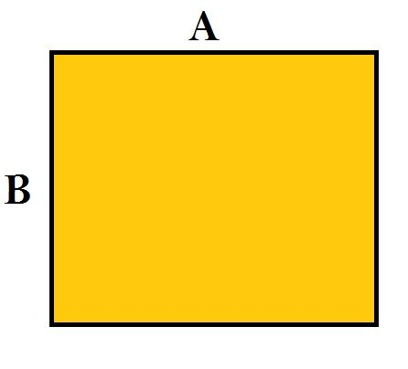 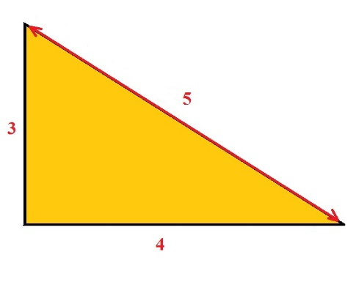
How to calculate area How to check for 90 degrees

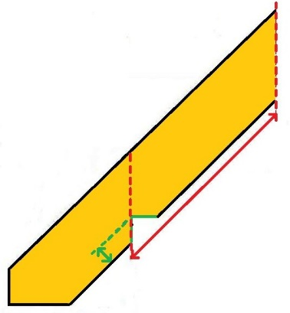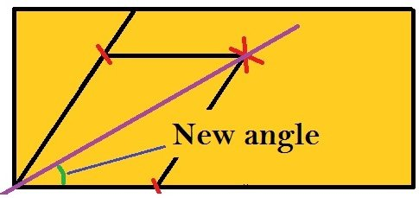
Calculate the length of a rafter How to bisect an angle

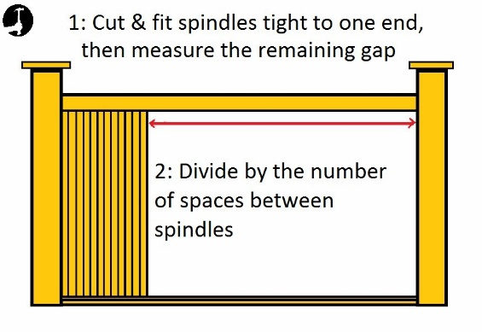
Calculate spindle spacings

Click on the link for learner views
https://www.youtube.com/watch?v=Ok066IUBA-0

Carpentry is a skilled craft that includes shaping, cutting, and installation of various building materials.
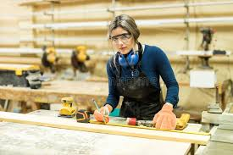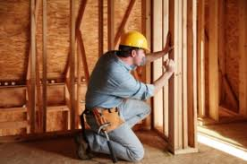
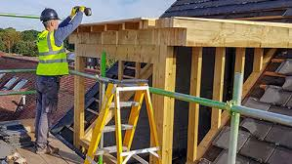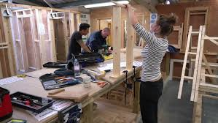
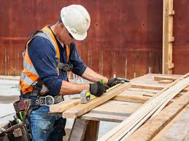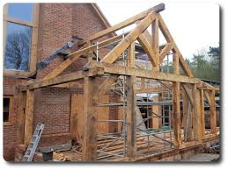
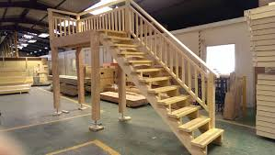
Try the carpentry quiz by clicking on the link!
https://play.howstuffworks.com/quiz/how-many-of-these-common-carpentryrelated-terms-do-you-know?remorapos=3&rmalg=es&remorasrc=c4cfcce33ae240689428f49d49b1eacd&remoraregion=rightrail

