A-Level Politics Summer Tasks Year 12
In the first few weeks of studying A-Level Politics we will consider the UK constitution, and the structure and role of parliament. Therefore, the following tasks are designed to help you begin to consider these topics and their importance in UK Government.
Task 1 : Demonstrate knowledge of the House of Commons by addressing the following questions-
How many MPs sit in the Commons and how often are they elected?________________________________________________________________________________________
By what electoral system are MP’s in the Commons elected?_____________________________________________
What are frontbenchers?__________________________________________________________________________
What are backbenchers?__________________________________________________________________________
What is a whip?__________________________________________________________________________________
What does the Speaker do?___________________________________________________________________________________________________________________________________________________________________________________________
Who is the current leader of the main opposition party?________________________________________________
What is parliamentary privilege?______________________________________________________________________________________________________________________________________________________________________________________
The Parliament Acts of 1911 & 1949 underpin the primacy of the lower chamber in legislation, what do the Acts say which gives these powers? ____________________________________________________________________________________________________________________________________________________________________________________________________________________________________________________________________________________________________________________________________________________________________________________________

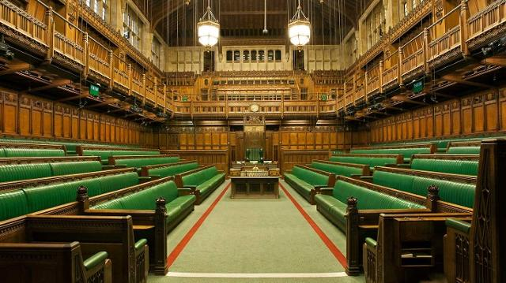

Task 2: Watch the following YouTube clip on the UK Constitution and annotate the diagram below with information on each section-
https://www.youtube.com/watch?v=8g_yZ97iFAo

Task 3: Explain with examples, why it may be advantageous for the UK constitution to be drawn from so many sources?
______________________________________________________________________________________________________________________________________________________________________________________________________________________________________________________________________________________________________________________________________________________________________________________________________________________________________________________________________________________________________________________________________________________________________________________________________________________________________________________________________________________________________________________________________________________________________________________________________________________________________________________________________________________________________________________________________________________________________________________
Task 4: Explain with three examples, the principle of parliamentary sovereignty.
- ________________________________________________________________________________________________________________________________________________________________________________________________________________________________________________________________________________________________________________________________________________________________________________________________________________________________________________________________________________________________________________________________________________
- ________________________________________________________________________________________________________________________________________________________________________________________________________________________________________________________________________________________________________________________________________________________________________________________________________________________________________________________________________________________________________________________________________________
- ________________________________________________________________________________________________________________________________________________________________________________________________________________________________________________________________________________________________________________________________________________________________________________________________________________________________________________________________________________________________________________________________________________

What skills can you gain from studying A-Level Politics?
While the content of A-Level Politics is niche, the skills gained from studying the subject are highly transferable and widely valued. Students learn to be able to relate international systems, unpick theory, analyse data, and formulate arguments about ever changing contexts.
Where can A-Level Politics take you?
As a result of the range of skills obtained from A-Level Politics students go on to enjoy fruitful careers within and outside of Politics. For example, local government and civil service roles, journalism, business management, international relations roles, teaching and much more!
What textbooks would help you study A-Level Politics at Sunderland Sixth Form?
https://www.amazon.co.uk/UK-Government-Politics-level-Fifth/dp/1471889238/ref=sr_1_3?crid=VXXKET8UIQGC&dchild=1&keywords=politics+a+level+textbook+AQA&qid=1588332323&sprefix=a-level+politics+te%2Caps%2C151&sr=8-3
https://www.amazon.co.uk/US-Government-Politics-level-Fifth/dp/147188936X/ref=sr_1_4?crid=VXXKET8UIQGC&dchild=1&keywords=politics+a+level+textbook+AQA&qid=1588332353&sprefix=a-level+politics+te%2Caps%2C151&sr=8-4
https://www.amazon.co.uk/Political-ideas-Level-Conservatism-Multiculturalism/dp/1471889513/ref=sr_1_6?crid=VXXKET8UIQGC&dchild=1&keywords=politics+a+level+textbook+AQA&qid=1588332378&sprefix=a-level+politics+te%2Caps%2C151&sr=8-6
Revision guides?
https://www.amazon.co.uk/My-Revision-Notes-level-Comparative/dp/1510447660/ref=sr_1_7?crid=VXXKET8UIQGC&dchild=1&keywords=politics+a+level+textbook+AQA&qid=1588332410&sprefix=a-level+politics+te%2Caps%2C151&sr=8-7
https://www.amazon.co.uk/My-Revision-Notes-level-Political/dp/1510447679/ref=pd_bxgy_img_3/279-1942157-5874330?_encoding=UTF8&pd_rd_i=1510447679&pd_rd_r=18c26121-53d6-401e-a40f-f389f8188763&pd_rd_w=VX9Mf&pd_rd_wg=pnj8U&pf_rd_p=106f838b-b7d1-46e9-83e0-f70facc857bf&pf_rd_r=PPG43K8H02JHHAJ4GQ56&psc=1&refRID=PPG43K8H02JHHAJ4GQ56
What else can you do to get ahead?
Produce profiles on Boris Johnson and Keir Starmer.
Demonstrate knowledge of the similarities and differences in UK and US Government.
Watch and take notes on PMQs to put in your files.
Have a little look at the subject content section on the AQA website, https://www.aqa.org.uk/subjects/politics/as-and-a-level/politics-7152/subject-content you can start to think about preparing a file and even investigating different parts of the modules you will study.

