**Sunderland Sixth Form: Transition Pack**

**CRIMINOLOGY**

|  |  |
| --- | --- |
| **QUALIFICATION** | **WJEC Applied Certificate/Diploma in Criminology** |
| Teacher Name(s) | Daniel Gibson |
| Contact email(s) | Daniel.gibson@sunderlandcollege.ac.uk |
| Recommended online learning | * <https://revisesociology.com/tag/criminology/> * <https://criminology.uk.net/> * <https://www.wjec.co.uk/en/qualifications/criminology-level-3/#tab_overview> * <https://howardleague.org/> |
| Textbooks that are used | Criminology Book One for the WJEC Level 3 Applied Certificate & Diploma by Rob Webb and Annie Townend  by Rob Webb  published by Napier Press      https://images-na.ssl-images-amazon.com/images/I/41F%2BsECf3VL._SX407_BO1,204,203,200_.jpg  by Rob Webb  published by Napier Press  WJEC Level 3 Applied Certificate & Diploma Criminology  by Carole Henderson  Published by Illuminate  WJEC Level 3 Applied Certificate and Diploma Criminology: Study and Revision Guide  by Carole Henderson  Published by Illuminate |

The transition pack may contain resources like PowerPoints, assessments and activities for you to try at home over the summer.

Please complete the activities in this booklet in readiness to begin your studies when we are told Sixth Form may reopen.

Good Luck and Stay Safe!

Dan

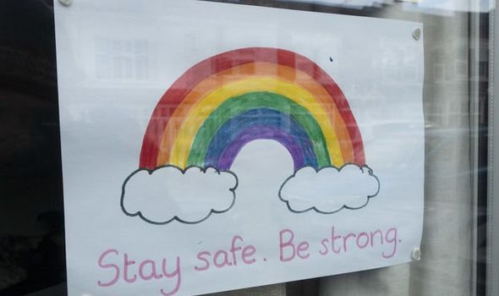

**Welcome to Applied Criminology**

You have chosen a subject that combines elements of psychology, law and sociology and that complements studies in humanities. Each unit has an applied purpose which demands that learning is related to case studies. It will certainly ‘keep you on your toes’ and make you think in ways you couldn’t imagine, and might challenge the way you think about certain topics such as justice, media representation and politics. You will certainly have a very different outlook on society and the criminal justice system by the end of the course.

**Overview of the course:**

This is a two-year course. UNITS 1 and 2 completed in the first year comprise an 8-hour Controlled Assessment plus a formal examination.

This is replicated in Year 2 with UNITS 3 and 4. You must **complete and pass ALL units** to gain the Diploma. The overall grades will be recorded on a scale A*-E.

Unit 1: Changing Awareness of Crime (Controlled Assessment)

Unit 2: Criminological Theories (Exam)

Unit 3: Crime Scene to Courtroom (Controlled Assessment)

Unit 4: Crime and Punishment (Exam)

Look at the specification for more detail about these topics. You can find this at: <https://www.wjec.co.uk/media/21xjkr24/applied-diploma-in-criminology-specification-from-2015.pdf>

You will be expected to **know and understand** the information covered, to be able to **apply** that knowledge and understanding and to be able to **analyse and evaluate** that knowledge and understanding.

***Task 1***

Read the specification carefully and make a note below of the sections there are to each Unit:

Changing Awareness of Crime…………………………………………………………..

.………………………………………………………………………………….………………

………………………………………………………………….............................................

Criminological Theories…………………………..………………………………………...

…………………………………………………………………………………………………..

…………………………………………………………………...……………………………..

Crime Scene to Courtroom………………………………………………………………..

…………………………………………………………………………………………………..

…………………………………………………………………………………………………..

Crime and Punishment in Society………………………………………………………..

………………………………………………………………………………………………….

…………………………………………………………………..………………………………

**Expectations of the course:**

* Lessons consist of taking notes, group discussions, watching relevant DVDs/documentaries, group work and PowerPoint presentations.
* Homework consists of note making, wider reading, research, past exam questions, power points and essays. It is expected that about 5 hours a week will be spent on Criminology homework.
* Your progress will be reviewed on a regular basis. The review process will provide feedback at specific times throughout the year. You will also be expected to be within two grades of your target grade on each piece of work.
* You are expected to use the resources available to you in the library and common room here and are strongly encouraged to use libraries outside of school, not just the internet.
* Make a Criminology chat/whatsapp for discussion.
* Your folders of notes will be checked on a regular basis to see if you are organised and up to date with your work.
* USE YOUR STUDY TIME AND BE PRO-ACTIVE.

*Resources:*

* A wide range of newspapers including The Guardian and Independent
* Any documentaries, including Panorama, Louis Theroux, Stacey Dooley, Mind of a Murderer
* Black Mirror series (Netflix)
* Goodfellas
* When They See Us (Netflix)
* Blood Diamond
* Ted Talks/Crime/Criminal Justice
* The Innocence Files (Netflix)
* Cold Case Files (Netflix)
* I Am A Killer (Netflix)
* When They See Us Now – Oprah Winfrey (Netflix)
* The Stanford Prison Experiment (Youtube)
* The Push – Derren Brown (Netflix)
* MacIntyre Undercover: The Chelsea Headhunters (Youtube)
* The Shawshank Redemption
* The Green Mile

***Task 2***

Choose something from the Reading and Watching List that you are going to report on in your first Criminology lesson.

***Task 3***

Watch the following clip and jot down 5 things that tell you what Criminology is.

<https://www.youtube.com/watch?v=tdaqqlFQdTE>

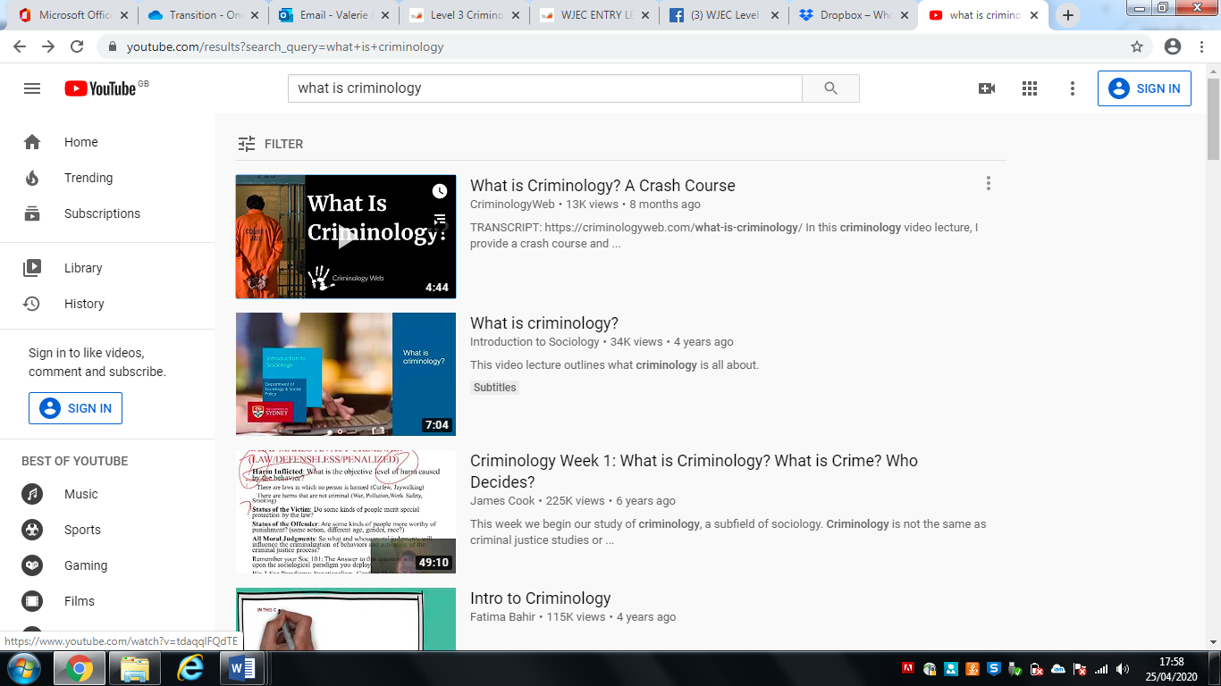

***Task 4***

What’s the difference between a crime and deviance?

A crime can be defined as ……………………………………………………………….

…………………………………………………………………………………………………..

Deviance is …………………………………………………………………………………..

…………………………………………………………………………………………………..

Examples of crimes are: …………………………………………………………………...

…………………………………………………………………………………………………..

Examples of deviance are: ……………………………………………………………….

…………………………………………………………………………………………………..

***Task 5***

Think of 3 different ways society has changed over the last 100 years. Try to be specific about the change eg. homosexuality is no longer illegal.

1. ……………………………………………………………………………………………..
2. ……………………………………………………………………………………………..
3. ……………………………………………………………………………………………..

Now, name 3 ways in which British society is different to another (America, Italy etc.)

1. ……………………………………………………………………………………………

…………………………………………………………………………

1. ……………………………………………………………………..

……………………………………………………………………………

1. ……………………………………………………………………………………………

…………………………………………………………………………………………………

***Task 6***

Famous Faces and their crimes? Or deviance? Match the famous face to the act of crime or deviance.



1. Trespassing and damage of property leading to loss of owner’s income
2. Arrested for possession and being under the influence of drugs, possession of an unloaded gun and trespassing
3. Arrested for protesting outside the South African embassy against unfair treatment of Black people in South Africa
4. Arrested for assault, driving under the influence of drugs, driving whilst license was suspended
5. Avoiding paying £20 million in tax that would help to pay for the NHS, Welfare and Schools in this country
6. Driving under the influence of alcohol and causing a collision injuring two other people

Answers at the end!

***Task 7***

Research the following types of crime. You need to understand the definition of the type of crime, the typical offender and the typical victim.

1. State Crime

Definition……………………………...............................................................................

.......................................................................................................................................

Typical Offender …………………………………………………………………………….

Typical Victim …………………………………………………………………………......

Example: ……………………………………………………………………………………

…………………………………………………………………………………………………

…………………………………………………………………………………………………

…………………………………………………………………………………………………

…………………………………………………………………………………………………

1. White Collar Crime

Definition……………………………...............................................................................

.......................................................................................................................................

Typical Offender …………………………………………………………………………….

Typical Victim ………………………………………………………………………….........

Example: ……………………………………………………………………………………...

…………………………………………………………………………………………………

…………………………………………………………………………………………………

…………………………………………………………………………………………………

…………………………………………………………………………………………………

1. Moral Crimes

Definition……………………………...............................................................................

.......................................................................................................................................

Typical Offender …………………………………………………………………………….

Typical Victim ………………………………………………………………………….........

Example: ……………………………………………………………………………………...

…………………………………………………………………………………………………..

…………………………………………………………………………………………………..

…………………………………………………………………………………………………

…………………………………………………………………………………………………

1. Technological Crimes

Definition……………………………...............................................................................

.......................................................................................................................................

Typical Offender …………………………………………………………………………….

Typical Victim ………………………………………………………………………………

Example: ……………………………………………………………………………………...

…………………………………………………………………………………………………

…………………………………………………………………………………………………

…………………………………………………………………………………………………

…………………………………………………………………………………………………

1. Hate Crime

Definition……………………………...............................................................................

.......................................................................................................................................

Typical Offender …………………………………………………………………………….

Typical Victim …………………………………………………………………………......

Example: ……………………………………………………………………………………...

…………………………………………………………………………………………………..

…………………………………………………………………………………………………

…………………………………………………………………………………………………

…………………………………………………………………………………………………

***Task 8***

As part of your course you will have to look at campaigns that have caused a change in the law. You will also have to plan your own campaign.

Conduct research on the following campaigns. Find out what the **original crime** was that sparked the campaign; what the **aim** of the campaign was; what **methods** were used (eg. TV interviews, advertising, wristbands, petitions, T-shirts etc) and whether the campaign was **successful**.

Sarah’s Law

The Double Jeopardy Law

Dignity in Dying

Snowdrop Campaign

Slow Down for Bobby

Anti-Foxhunting Campaign

***Task 9***

Research how newspapers report crime and the types of crime they report on. Consider differences between local newspapers, national newspapers, tabloids and broadsheets in their reporting of crime.

Newspaper 1

Name: …………………………………………………………………………………………

Types of crime reported: ………………………………………………………………….

……………………………………………………………………………………………….....

…………………………………………………………………………………………………..

…………………………………………………………………………………………………..

Examples of headlines/language used: ……………………………………………….

…………………………………………………………………………………………………..

…………………………………………………………………………………………………..

…………………………………………………………………………………………………..

Newspaper 2

Name: …………………………………………………………………………………………

Types of crime reported: ………………………………………………………………….

……………………………………………………………………………………………….....

…………………………………………………………………………………………………..

…………………………………………………………………………………………………..

Examples of headlines/language used: ……………………………………………….

…………………………………………………………………………………………………..

…………………………………………………………………………………………………..

…………………………………………………………………………………………………..

Newspaper 3

Name: …………………………………………………………………………………………

Types of crime reported: ………………………………………………………………….

……………………………………………………………………………………………….....

…………………………………………………………………………………………………..

…………………………………………………………………………………………………..

Examples of headlines/language used: ……………………………………………….

…………………………………………………………………………………………………..

…………………………………………………………………………………………………..

…………………………………………………………………………………………………..

Newspaper 4

Name: …………………………………………………………………………………………

Types of crime reported: ………………………………………………………………….

……………………………………………………………………………………………….....

…………………………………………………………………………………………………..

…………………………………………………………………………………………………..

Examples of headlines/language used: ……………………………………………….

…………………………………………………………………………………………………..

…………………………………………………………………………………………………..

…………………………………………………………………………………………………..

***Task 10***

Design a poster or a cover to advertise a new electronic crime game for a console or PC. Consider the implications of new technologies on crime and crime prevention.

***Task 11***

Research how the terrorist attack on the ‘Twin Towers’ in New York in 2001 led to a change in how the British police and government changed their emphasis and priorities on crime. (Type ‘police and terrorism since 2001 in England and Wales’ into Google).

***Task 12***

Go to the Police UK website http://www.police.uk/ type in your local postcode and look at the crimes in the local area. Consider which crimes the police should be focusing their resources.

***Task 13***

Research the case of Ruth Ellis. Ellis was convicted of murder and was hanged in 1955. Find out whether Ellis should have been convicted of murder or manslaughter. Explain why this judgement is made. Complete further research on the Ellis case and decide how she could have been defended from being hanged.

***Task 14***

Take the Eye Witness Testimony test. Watch the video. When it tells you to pause, write down what you remember about the criminal.

<https://www.youtube.com/watch?v=c6eknHXGM0c>

Description:

Gender: ………………………………………………………………………………………

Hair colour and length: ……………………………………………………………………

Clothing: ……………………………………………………………………………………...

Anything else significant: ………………………………………………………………….

…………………………………………………………………………………………………..

Were you right?

Now look at how the unreliability of eye witness testimony can affect real cases.

<https://www.youtube.com/watch?v=u-SBTRLoPuo>

**Task 15**

As part of the course, we have to look at the process of what happens from the crime scene up until the defendant is charged in court. Watch the documentary on Netflix of Amanda Knox. Then watch the BBC documentary on Youtube: <https://www.youtube.com/watch?v=erla7Ley4Tw>

Record your views on the case following each documentary. What differences do you notice?

***Nature vs Nurture – The Big Debate***



There are many ways of explaining why certain people do things in certain ways. For example, biologists think that people behave as they do because they are controlled by nature. This is known as **Nature theory**. Humans are compared to animals and seen to act on **instinct**.

Sociologists believe that people behave as they do because they are taught how to behave. For example, the sociologist Michael Haralambos states, ‘Human beings learn their behavior and use their intelligence whereas animals simply act on instinct.’ This is known as **Nurture theory**. Nurture means the way you are brought up. It is also a reference to **socialization**, the lifelong process by which we learn our culture, values, norms and how to behave.

***Task 16***

Research the childhood backgrounds of any notorious serial murderers such as Fred West or Harold Shipman. The focus should be on life history and not subsequent crimes. Thinking about what you have read about Nature and Nurture, which explanation could account for their criminal behaviour?

***Task 17: Essay***

This essay is designed to allow you to demonstrate your understanding and writing skills.

You will be assessed on the quality of your written style, the level to which you have understood and can use key concepts, your organisational skills and ability to follow instructions.

|  |
| --- |
| **Essay title:**  To what extent did childhood experiences either indicate developing problems or appear to contribute to the later offending behaviour?  You will need to select a criminal to write about and pay particular attention to what you have read about nature and nurture. Further research will also be required. |

Your essay should have:

* Clear paragraphs, an introduction and conclusion
* Accurate spelling, punctuation and full sentences
* Correct use of grammar
* Accurate phrasing
* A discussion of BOTH nature and nurture, explaining which theory best suits the behaviour of the criminal you have chosen to write about.

**Your essay should be at least 500 words and *hand written*.**

**You should hand in your essay when directed on your return to 6th Form.**

***Task 18: Key Words***

Find out what the following key words mean.

|  |  |
| --- | --- |
| *Key Term* | *Definition* |
| Criminology |  |
| Crime  Social Definition  Legal Definition |  |
| Deviance |  |
| Genocide |  |
| Nature/Nurture |  |
| Decriminalisation |  |
| Moral Panic |  |
| Norms |  |
| Civil Liberties |  |
| Statute |  |
| Miscarriage of justice |  |

Answers to Task 6

1. Trespassing and damage of property leading to loss of owner’s income
2. Arrested for possession and being under the influence of drugs, possession of an unloaded gun and trespassing
3. Arrested for protesting outside the South African embassy against unfair treatment of Black people in South Africa
4. Arrested for assault, driving under the influence of drugs, driving whilst license was suspended
5. Avoiding paying £20 million in tax that would help to pay for the NHS, Welfare and Schools in this country
6. Driving under the influence of alcohol and causing a collision injuring two other people
7. Ant McPartlin – F
8. Lindsay Lohan – D
9. Robert Downey Jr – B
10. Gary Barlow – E
11. Jeremy Corbyn – C
12. Theresa May - A