Y11 Introduction to Law
Independent Study Booklet
Summer 2020

Law Lecturer – Rebecca Richards
Rebecca.richards@sunderlandcollege.ac.uk

Your Name:

Welcome! If you would like to explore Law either in anticipation of studying Law in Autumn, or just for fun, then this is one place to start…

There are a variety of tasks for you to have a go at and explore some of the key ideas and aspects of law that we will explore during the next couple of years.

You can submit this by email, or bring it with you in the autumn term for a little Law Prize! I will be on email if you would like to ask any further questions, or links aren’t working.

You will also find, at the end, a suggested ‘watch list’ of documentaries and films which are relevant to law (and some that are just great fun!)

Task No. | Outline | Completed  Please date | MAH Comment on your response | R | A | G
1 | Reflection on current sentencing practice
2 | Operation of the Supreme Court
3 | Case study on the operation of the Criminal Justice System & Young Offenders
4 | Changing the Law: Double Jeopardy
5 | Case Study: You be the Judge (Sentencing)
Task One: Reflection on Sentencing

Why do prisoners only serve half their term? (bbc.co.uk)

Using a range of the information, produce a summary of the current operation of sentencing in England and Wales in the space below. You may present the information in any format you like, but it must cover the questions below and must not simply be copy and paste.

What influences the sentence the judge hands down? | What type of sentences may a judge hand down? | Why do most offences offer a range of options? | How does a judge decide which tariff to hand down for murder? | When are most offenders released and what happens to them?

Challenge: Why do you think that people are often upset or confused by the sentences handed to offenders?

Task Two: Supreme Court
What is the UK Supreme Court? (bbc.co.uk)
and watch this documentary available on youtube: https://www.youtube.com/watch?v=PZtYENfNa7k
Using a range of the information on in the source, complete each of the information boxes below. Remember to include relevant legal terminology accurately used.

Sum up the kind of cases and decisions that it has made over the last years:
Name and Location:

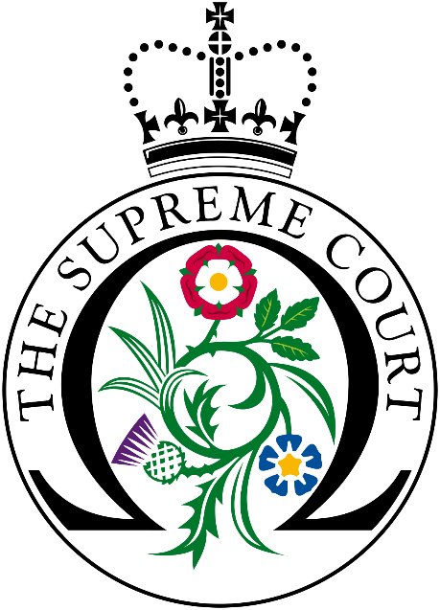

Make up of the court: What issues do you see
With who is on the court (pros and cons)?
What powers does it have (and what can’t
it do?:

Exploring a Case:
Pick one of the cases which the article or documentary highlights. Summarise the facts, question and decision by the court. End with a critical comment on your view of the case and decision:

Critical Response:

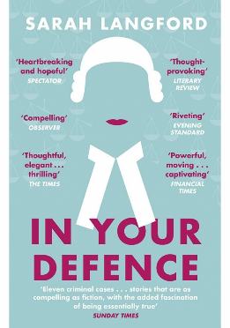
Task Three: Operation of the Legal System
Sarah Langford: In Your Defence

Langford is a practising defence barrister and wrote this book to highlight some of the key issues within the law that she saw. It is very readable, and uses 11 cases to illustrate different issues within the law. Each chapter begins with the ‘action’ of the case, and then switches to the case and her role and perception of the issues within it.

Rather than by purchasing the book, you can look inside the book on amazon:
https://www.amazon.co.uk/Your-Defence-Stories-Life-Law-ebook/dp/B074MC25S2/ref=sr_1_4?crid=3ARANPAS7XMWN&dchild=1&keywords=the+secret+barrister&qid=1587649692&sprefix=the+secret+barri%2Caps%2C147&sr=8-4

You are going to read Case 1: Dominic.

Particulars of the first offence (what happened): | Prior Offending history:
What concerns did Langford have about representing him in the Magistrates Court? |  | View of the police:
What was the judgement of the court on the first offence and why? |  |  | Critical Response: how far do you agree with Langford on the outcome for this first offence?
Particulars of the second offence (what happened): | What issues surrounding sentencing and remand are raised in this section?
What sentence was handed down to Dominic for this first case and why did that cause issues for both Sarah and Dominic?

Critical Thinking: How would you address the issues brought up by this chapter?

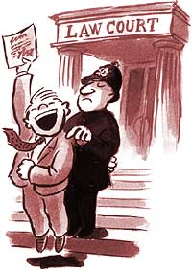
Task Four: Changing and reforming the law
Double Jeopardy
Watch the episode on BBC iPlayer: Catching Britain’s Killers: The Crimes that Changed Us (Episode 2) Warning: there may be details which are upsetting.

P.S. the other two episodes are excellent as well… take a look!

- What issue was raised by the case of Donald Hume?

- What were the facts of the case of Julie Hogg?

- What evidence was there that Dunlop may have been responsible for it?

- What did the jury decide at the trial and what impact did this have?

- What was the aim of the double jeopardy law?

- What impact did the Stephen Lawrence report (McPherson Inquiry) have on double jeopardy?

- What further charges did Billy Dunlop face and what was the evidence to support them? What sentence did he receive?

- How does this case illustrate lobbying by both individuals and MPs/Peers?

- What other legal principle would be affected by the change to the law on double jeopardy?

- Why was Julie Hogg’s mother still apprehensive following the White Paper?

- What are the criteria for double jeopardy to be set aside?

- Explain one of the further cases affected by double jeopardy change.

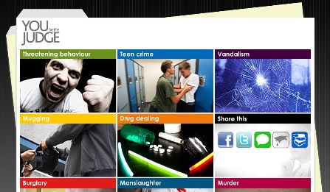
Task Five: Case Studies
You Be the Judge

Task: go to: http://ybtj.justice.gov.uk/. You will need sound as you are going to work through two cases, completing the questions below as you go. Burglary & Harassment

Please note: there are other cases you can have a look at, but these two you must complete for this task!

Defendant One: Alexander Jackson
What did he do?

What was the plea?

Which court was it heard in and why?

Who determines sentencing for the defendant?

Relevant information from the police officer: | Relevant information from the Victim:

Will the fact that the victims were at home at the time of the break-in affect your sentence?

No

Yes
Not sure

Judge’s response:

Do you think the fact that an item of sentimental value was taken is significant?

No

Yes
Not sure

Judge’s response:

Mitigating Factors | Aggravating factors

Would a genuine commitment from Alex to come off drugs affect your sentence?

No

Yes
Not sure

Judge’s response:

What other circumstances might be relevant in sentencing:

Sentence choices:

- Prison: 2.5 years ( ½ in custody + ½ monitored in the community )
- Prison: 3.5 years ( ½ in custody + ½ monitored in the community )
- Prison: 4.5 years ( ½ in custody + ½ monitored in the community )
- Prison: 6 years ( ½ in custody + ½ monitored in the community )

I would chose option because…

He was actually given option because…

What is the purpose of sentencing Alex? Link to the aims of sentencing – which do you think was uppermost in the judge’s mind

Defendant Two: Chris Williams
What did he do?

What was the plea?

Which court was it heard in?

What is the relevant evidence from the victim? | Relevant information from the defendant?

Will the fact that Mrs Dixon is elderly influence your sentence?

Yes
Not sure
No

Judge’s response:

Do you think the fact that Chris was provoked is significant?

Yes
Not sure
No

Judge’s response:

Mitigating Factors | Aggravating factors

Will the fact that Chris pleaded guilty from the start affect your sentence?

No

Yes
Not sure

Judge’s response:

Sentence choices:

- Fine: £300
- Community sentence: 80 hours unpaid work + £100 compensation + £90 costs
- Community sentence: 200 hours unpaid work + weekly supervision meetings with a probation officer for 2 years
- Prison: up to 3 months ( ½ in custody + ½ monitored in the community )

I would chose option because…

He was actually given option because…

What is the purpose of sentencing Chris? Link to the aims of sentencing – which do you think was uppermost in the Magistrates’ mind.

Below are a range of documentaries and legally linked films…

Title | Origin | Link (if available)
Catching Britain’s Killers | iPlayer (BBC) | https://www.bbc.co.uk/iplayer/episode/m0009dz2/catching-britains-killers-the-crimes-that-changed-us-series-1-2-double-jeopardy
The Case of Sally Challen | iPlayer (BBC) | https://www.bbc.co.uk/iplayer/episode/m000c65v/the-case-of-sally-challen
Crime and Punishment (History of the Law) | YouTube | https://www.youtube.com/watch?v=kn1gdZMLtrk
The Briefs | YouTube | https://www.youtube.com/watch?v=QWTcg8Ye6fI
HARDtalk interview with Lady Hale | YouTube | https://www.youtube.com/watch?v=i1VozJR_jC8&t=414s
The Bar | YouTube | https://www.youtube.com/watch?v=6d78ROXCPgI
To Kill a Burglar | YouTube | https://www.youtube.com/watch?v=BemcOAg53eM
The Trial: Murder in the Family | All4 | https://www.channel4.com/programmes/the-trial-a-murder-in-the-family

